

INFORMATICS INSTITUTE OF TECHNOLOGY

in collaboration with

University of Westminster, UK

BEng. (Hons) in Software Engineering

Reasoning about programs

**Spaceship & Asteroids Game**

using the B Tools Atelier B & ProB

By

Rehan Sewranga Samarasekera

IIT number – 2015065

UOW number - 1583026

Module leader - Mr. Tharindu Wickramaarachchi

Table of Contents

1. Structure Diagram 3

2. Description of the part of the machine 3

2.1 Sets Description 3

2.2 System Invariants Description 4

# Structure Diagram

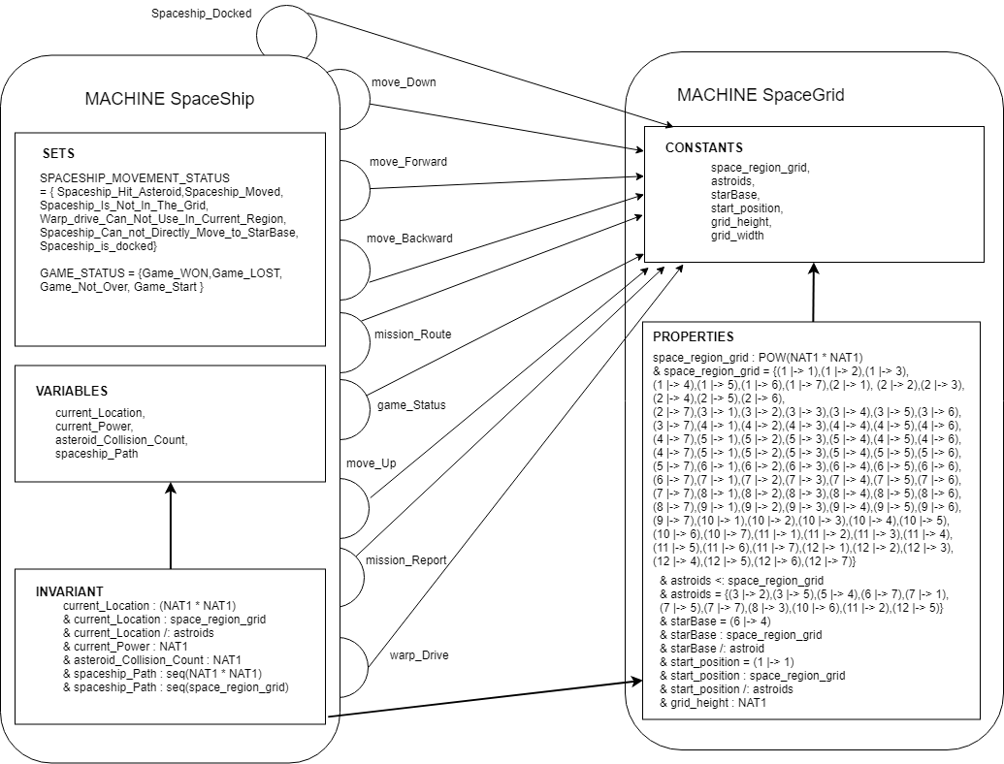

# Description of the part of the machine

# Sets Description

SPACESHIP_MOVEMENT_STATUS = {Spaceship_Hit_Asteroid, Spaceship_Moved, Spaceship_Is_Not_In_The_Grid, Warp_drive_Can_Not_Use_In_Current_Region, Spaceship_Can_not_Directly_Move_to_StarBase, Spaceship_is_docked};

* Explanation: - This set used for representing the spaceship movement. When spaceship move up, down, right, left, hit asteroids and docked in star base this message are display

GAME_STATUS = {Game_WON,Game_LOST,Game_Not_Over,Game_Start}

* Explanation: - This set used for representing space game status. When spaceship move to star base message display game won. When power is zero, message game lost, In other movements its display game not over.

# System Invariants Description

*current_Location : (NAT1 * NAT1)*

*& current_Location : space_region_grid*

*& current_Location /: astroids*

* Explanation: - Current location coordinate is an element of natural numbers starting from one and this coordinate is an element of the space region grid, but current location coordinates are not element of the asteroids.
* Simple English Explanation: - Spaceship must move within the shape region grid.

*& current_Power : NAT*

* Explanation: -Power is an element of natural numbers
* Simple English Explanation: - Spaceship must have power to move

*& asteroid_Collision_Count : NAT1*

* Explanation: - Asteroid count is an element of the natural numbers starting from one.
* Simple English Explanation: - asteroid count must have to display status of the mission report.

*& spaceship_Path : seq(NAT1 * NAT1)*

*& spaceship_Path : seq(space_region_grid)*

* Explanation: -Spaceship path is an element of the natural number sequence. And it also element of the space region grid sequence.
* Simple English Explanation: - Spaceship must move Inside of the shape region grid.